CO4-AT2
INDUSTRY PROBLEM SOLVING TASK
Course code:ITA0506 Karanam Meghana
Course name: Computer vision 192321126

1. Autonomous Vehicle Vision System Selection
An automobile company is developing an autonomous vehicle detection system that must
operate under the following conditions:
- If accuracy &lt; 90% → system fails
- If latency &gt; 70 ms → unacceptable
- The vehicle supports moderate computational resources
Methods available:
- Viola-Jones: 82% accuracy, 30 ms latency, low computation
- YOLO: 93% accuracy, 60 ms latency, moderate computation
- Deep Learning: 97% accuracy, 90 ms latency, high computation
Task:
Compare the three methods and evaluate which method satisfies all the constraints. Justify your
decision using logical reasoning based on accuracy, latency, and computational requirements.

2. Smart Factory Product Inspection Selection
A manufacturing company wants to deploy a real-time computer vision system to detect
defective products on a production line. The system must operate under the following conditions:
- If accuracy &lt; 95% → defects may be missed
- If processing time &gt; 50 ms → production is affected
- Hardware supports moderate computation
Methods available:
- Traditional Image Analysis: 91% accuracy, 25 ms, low computation
- YOLO: 96% accuracy, 45 ms, moderate computation
- Deep Learning: 98% accuracy, 75 ms, high computation
Task:
Compare the three methods and evaluate which method satisfies all the constraints. Justify your
decision using logical reasoning based on accuracy, processing time, and computational
requirements.

ANSWERS
1. Autonomous Vehicle Vision System Selection
An autonomous vehicle requires a vision system that can detect objects accurately and quickly. The given constraints are:
- Accuracy must be ≥ 90%
- Latency must be ≤ 70 ms
- Computational resources are moderate
Method | Accuracy | Latency | Computation | Constraint Result
Viola-Jones | 82% | 30 ms | Low | ❌ Fails accuracy
YOLO | 93% | 60 ms | Moderate | ✅ Satisfies all
Deep Learning | 97% | 90 ms | High | ❌ Fails latency & computation
Viola-Jones
Viola-Jones has a latency of only 30 ms, so it satisfies the latency requirement. It also requires low computational resources, which is suitable for the available hardware. However, its accuracy is only 82%, which is below the required 90%. Therefore, it cannot be selected because inaccurate object detection can create serious safety risks in an autonomous vehicle.
YOLO
YOLO provides 93% accuracy and 60 ms latency. Its accuracy is above the required 90%, and its latency is below the maximum acceptable value of 70 ms. It also requires moderate computation, which matches the computational resources available in the vehicle.

Therefore:
- Accuracy: 93% ≥ 90% ✅
- Latency: 60 ms ≤ 70 ms ✅
- Computation: Moderate ✅
Deep Learning
Deep Learning provides the highest accuracy of 97%, which satisfies the accuracy requirement. However, its latency is 90 ms, which exceeds the maximum allowed 70 ms. It also requires high computational resources, while the vehicle supports only moderate computation. Therefore, it cannot be selected.
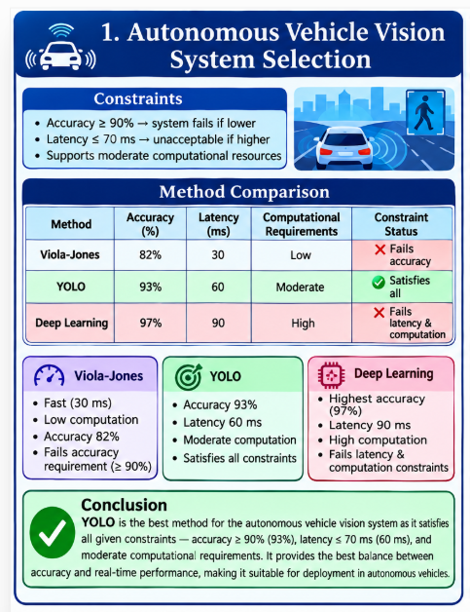
Conclusion
YOLO is the best method and satisfies all the given constraints. It provides sufficient accuracy, acceptable latency, and moderate computational requirements. Although Deep Learning has higher accuracy, its latency and computational requirements make it unsuitable. Viola-Jones is fast and computationally efficient but fails the accuracy requirement.
Final Selection: YOLO (93% accuracy, 60 ms latency, moderate computation).

2. Smart Factory Product Inspection Selection
The manufacturing company needs a real-time vision system that can identify defective products without slowing down the production line.
The constraints are:
- Accuracy must be ≥ 95%
- Processing time must be ≤ 50 ms
- Hardware supports moderate computation
Method | Accuracy | Processing Time | Computation | Constraint Result
Traditional Image Analysis | 91% | 25 ms | Low | ❌ Fails accuracy
YOLO | 96% | 45 ms | Moderate | ✅ Satisfies all
Deep Learning | 98% | 75 ms | High | ❌ Fails processing time & computation
Traditional Image Analysis
Traditional Image Analysis has a processing time of only 25 ms and requires low computational resources. Therefore, it is fast and inexpensive to deploy. However, its accuracy is only 91%, which is below the required 95%.
Since defective products could be missed, this method is not suitable for the given application.
YOLO
YOLO achieves 96% accuracy with a processing time of 45 ms. It requires moderate computation, which matches the available hardware.
Therefore:
- Accuracy: 96% ≥ 95% ✅
- Processing time: 45 ms ≤ 50 ms ✅
- Computation: Moderate ✅
YOLO satisfies all three constraints and can inspect products in real time without significantly affecting production.

Deep Learning
Deep Learning provides the highest accuracy of 98%, so it satisfies the accuracy requirement. However, its processing time is 75 ms, which exceeds the maximum acceptable 50 ms. It also requires high computational resources, while only moderate computation is available.
Therefore, DeepLearning isnotsuitable despite its higher accuracy. 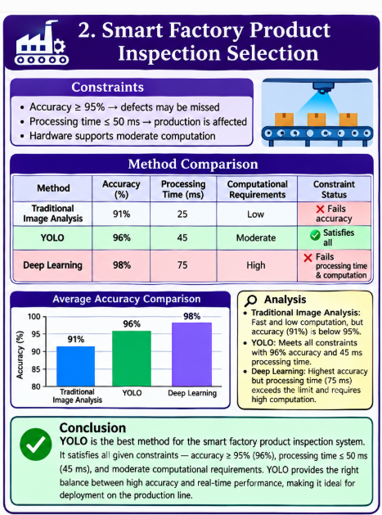
Conclusion
YOLO is the best method for the smart factory product inspection system. It provides sufficient accuracy of 96%, fast processing of 45 ms, and moderate computational requirements. Traditional Image Analysis is faster but does not provide sufficient accuracy, while Deep Learning is more accurate but too slow and computationally expensive.

